If you can’t be without your licence, know your limit and your options with a quick test.

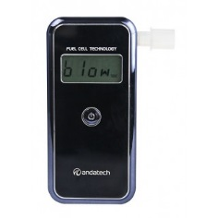
Stealth Professional Breathalyser
Fuel Cell Breathalyser
Sleek, small and accurate. Latest technology, stylish, lightweight design.
*Electrochemical fuel cell sensor - high accuracy and reliability.
*Australian Standard AS3547 Certified * Accuracy +/- 0.005% BAC at 0.100%BAC
*High accuracy with 3-decimal reading * Ideal for accurate personal use
*Indication of B.A.C 0.000 to 0.400%BAC (Full 3 decimals)
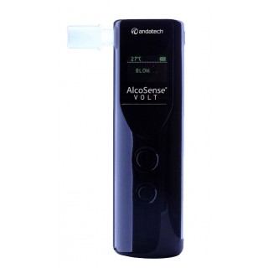

Portable Charging Breathalyser
Features accurate fuel cell sensor, rechargeable battery and also functions as a portable charging station. Practical and multifunctional breathalyser that is a must-have for those who are always on-the-go.
*Rechargeable internal battery * Last reading recall, temperature and flashlight
*Supercharge your social life! * Highly accurate 3-decimal place
* Portable charging station for mobile phones & cameras

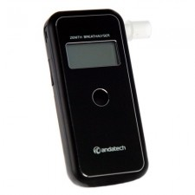
Corporate “Z” Breathalyzer
Perfect for on the go. Compact, lightweight, easy to use, with data-saving capabilities. *Highly accurate hand-held device for personal and professional use
*Easily replaced recalibrated sensor *Low battery indication
*BAC Range: 0.000~0.400% BAC. *Accuracy: +/- 0.010% BAC.
*Audible alert when alcohol detected.

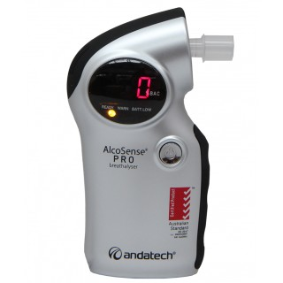
PRO 2013 Professional
World first breathalyser that can be operated in dual-mode; it can be operated in a normal mode
to measure specific blood alcohol concentration, or it can be used as an alcohol responder
* Certified Australian Standard AS3547 * Perfect for professional and personal use
*Accuracy: +/- 0.010% at 0.050% BAC * 12 Month Manufacturer’s Warranty
* New oxide semiconductor-type alcohol sensor

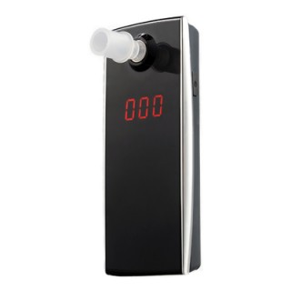
Elite 2013 Breathalyser
Simple to use. Microcomputer-controlled automatic test sequence with a 2 decimal LCD display, audible warnings on the detection of alcohol. Exceptionally light, conveniently sized, easy storage.
*Accurate hand-held device *Breath flow check
*Sensor Type New Oxide Semiconductor *Indication of BAC0.00% to 0.4% BAC
*Warranty 6 Months

